**Prerequisites of Azure Core**

**Region :**

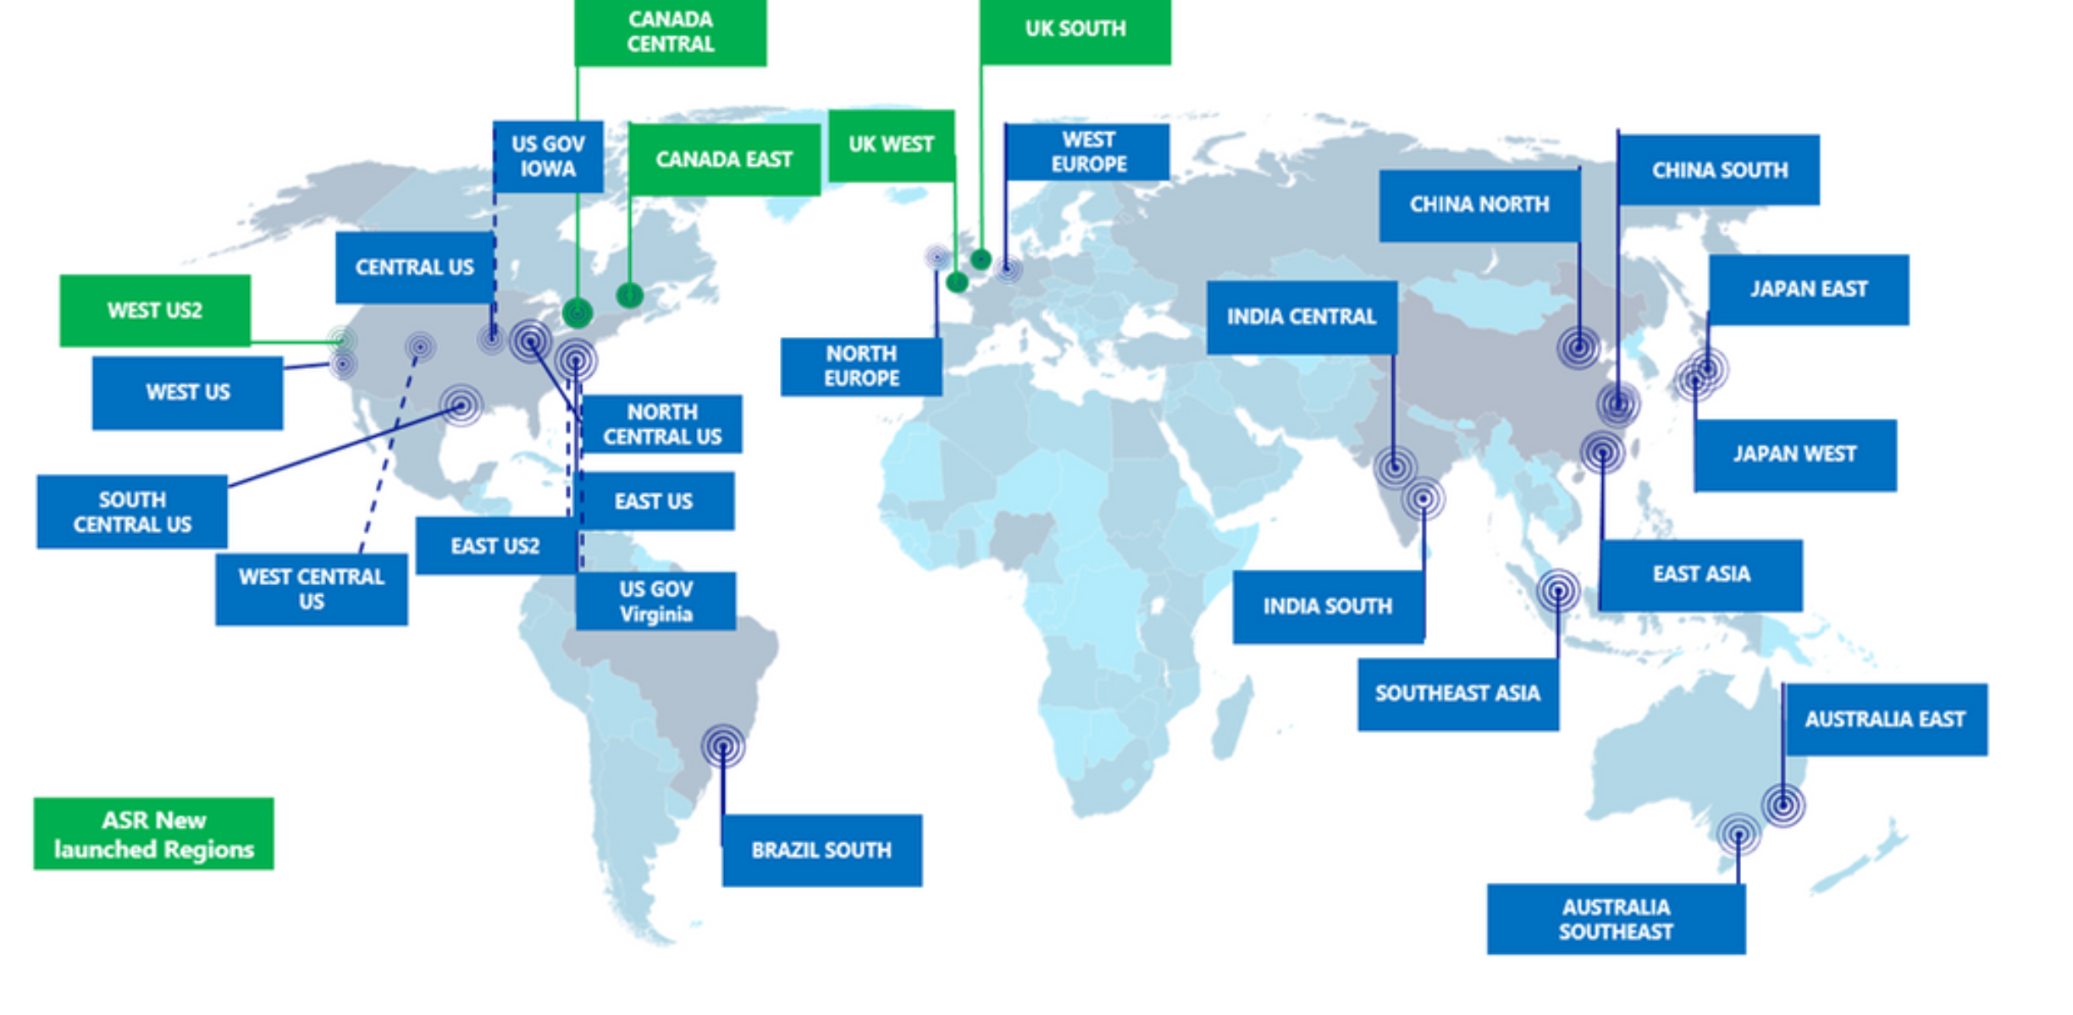

**Azure Resource** **Hierarchy :**

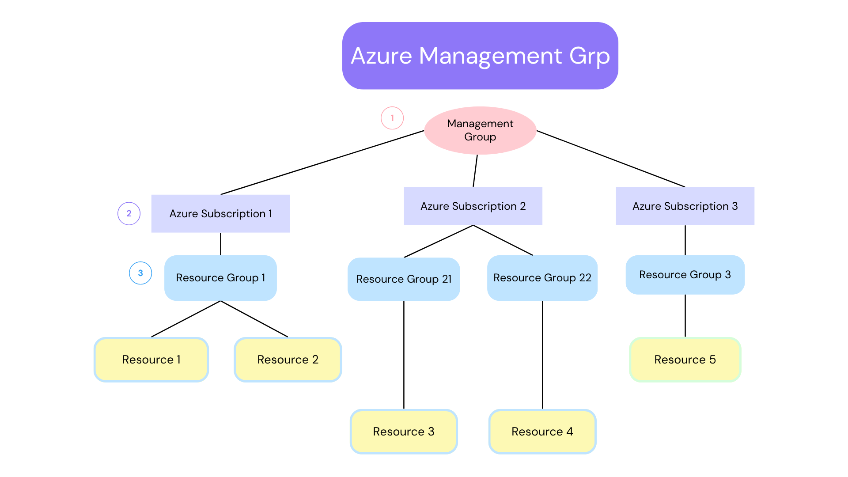

**Management** **Group :** Top-level container used to manage access, policies, and compliance across multiple subscriptions. Ideal for enterprise environments.

**Azure** **Subscription :** Logical unit for billing and resource access control. Each subscription has its own set of resources and quotas.

**Resource** **Group :** Container within a subscription that holds related Azure resources. Resources in a group share a lifecycle.

**Resource :** The actual service you use, like Virtual Machines, Storage Accounts, Databases, etc.